Risk Management
COVID-19 Data Update-September 16, 2021
The following is the most recent School Reopening Benchmark data for our district (According to Maricopa County Public Health). We have maintained a High Transmission level.
Community Transmission Level is: HIGH TRANSMISSION.
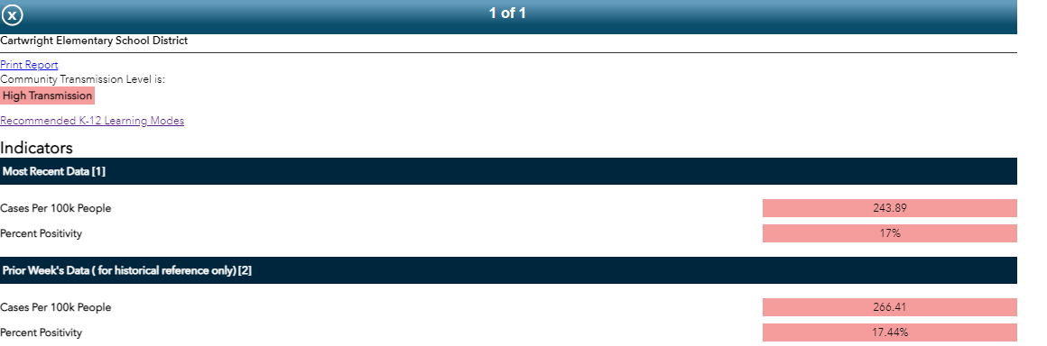
To see this data at your community level (by city, zip code, or school district), look at the Maricopa County school reopening dashboard.

Dashboard last updated: September 16, 2021.
The graph history has been modified to more accurately view the current trends in our community and district. Data has been condensed to show metrics since June 3, 2021.
Community Transmission Level is: High Transmission

The charts below displays our current trend within our area (AZDHS) and the district. The graph history has been modified to more accurately view the current trends in our community and district. Data has been condensed to show metrics since 06/03/2021.
Last updated: September 16, 2021

